|  |
| --- |
| CURRICULUM VITAE  MICHELLE VAN DER WESTHUIZEN |

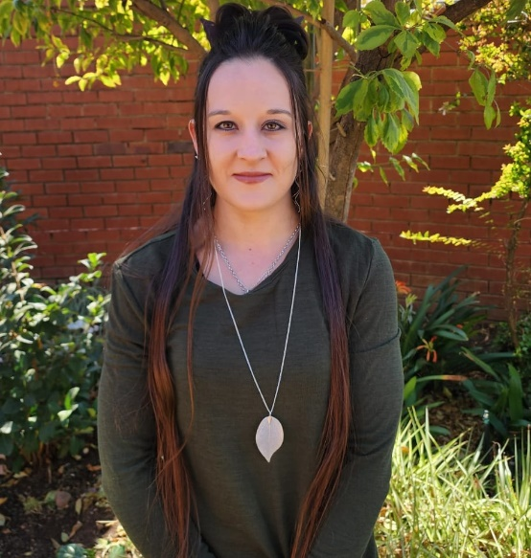

About me

**Attitudes Strengths**

Energy and drive Extrovert

Passionate Dedicated

Practical Honest

Adaptable to change Organised

Approachable Logical reasoning

Logic in decision making Problem solving

Persuasive Eager to learn new skills

High drive and competitive Non-smoker & drinker

Responsible

Contact Details

**Address:**

Garsfontein, Pretoria

**Email:**

cawoodmimi@gmail.com

michellevdw2021@gmail.com

Language

**Home language**: Afrikaans

**Other language**: English

Hobbies

* Exercising
* Hiking
* Reading

**Introduction**

I’m someone who believes in hard work, responsibility, and honesty. I’m excited about diving into the world of software development and expanding my skill set. Always on the lookout for new challenges, I love pushing myself to grow and improve in whatever I do. I genuinely enjoy working and take pride in giving my best to achieve goals. I want to ensure that I benefit the Company that I work for.

**Education**

* Matriculated in 2013
* Nature Management NQF5
* Programming Foundation NQF4
* Systems Development NQF5 (current part-time)

**Certifications**

* DP – 900 Microsoft Azure Data Fundamentals **2022**
* 98 – 381 Introduction to Programing Using Python **2022**
* 98 – 382 Introduction to Programing Using JavaScript **2023**
* 98 – 383 Introduction to Programing Using HTML & CSS **2023**
* AZ-204 Developing Solutions for Microsoft Azure **2023**
* AZ-400 Designing and Implementing Microsoft DevOps Solutions **2024**

**Skills Highlights**

* Good communication skills
* Teamwork
* Self-management
* Learning
* Computer Skills

**Experience**

* 2019 - **current** ICO - Accounting Solutions – **Administrator / Clerk**
* 2018 - 2019 Uni-Vision – **Personal assistant /** **Administrator**
* 2016 - 2017 Ray Cammack Shows – **Game attendant**
* 2015 Letsatsi la Africa – **Animal caretaker**



CURRICULUM VITAE

MICHELLE VAN DER WESTHUIZEN

**SECONDARY QUALIFICATIONS**

**Grade 12** Matriculated in 2013 at the Montana High School, in Pretoria.

**Major subjects**:Afrikaans

English

Mathematics

Life Orientation

Tourism

Hospitality studies

CAT (All basic MS Office packages as per NQF level 3.

**TERTIARY QUALIFICATIONS**

**Institute:** Centurion Academy, Pretoria

**Year of study completion:** 2014

**Qualification level:** Nature management NQF5

**Major Subjects:** Wildlife Diseases

Soil Science

Ecology

Game Ranch Management

Conservation Communication

Animal Science

Field Management

Conservation Development

**Institute:** CTU Training Solutions

**Year of study completion:** 2022 - 2023

**Qualification level:** Systems Development NQF4

**Major Subjects:** Principles of Program Design

Computer Architecture

Digital Literacy & Proficiency

Programming with Python

Core Web Development

Robotics Development

Ethics & Network Architecture

Cloud Fundamentals



CURRICULUM VITAE

MICHELLE VAN DER WESTHUIZEN

**Institute:** CTU Training Solutions

**Year of study completion:** 2023 – current (Part-time)

**Qualification level:** Systems Development NQF5

**Major Subjects:** Beginner Java

Programming with C#

Solutions Development

Developers and Operations Engineering

Advanced Java

Business Programming



CURRICULUM VITAE

MICHELLE VAN DER WESTHUIZEN

**EMPLOYMENT HISTORY**

**February 2018 - current**

**Industry:** Accounting

**Company:** ICO-Accounting Solutions (Pty) Ltd

**Position:**  Administrator / Clerk

**Duties:**  Working on CIPC, SARS and Pastel

Legal administrative work like creating share transfer and certificates.

Working with Trusts.

**Reason for leaving:** I needed time to find out what career I wanted to pursuit, now I am busy with my studies and seeking growth in the software development field.

**February 2018 - 2019**

**Industry:** Time share / Resorts

**Company:** Uni-Vision

**Position:**  Personal assistant / Administrator

**Duties:** Research

Capturing slips on Oracle

Arranging payments

Stock taking and ordering

Creating data sheets on excel

Managing and reviewing filing and office system.

Finding suppliers

Reporting on Progress / Follow up on all outstanding project issues

Diary management / Scheduling of meetings

Arrange delivery of correspondence and documents

**Reason for leaving:** ICO - Accounting Solutions is part of the Uni-Vision group



CURRICULUM VITAE

MICHELLE VAN DER WESTHUIZEN

**February 2016 - November 2017**

**Industry:** Carnival

**Company:** Ray Cammack Shows - In USA

**Position:**  Game attendant

**Duties:**  Set up and tear down of all games.

Cleaning inside and around the games.

Interacting with guest.

Stock ordering, data capturing and management

Training and supervising of temporary workers

**Reason for leaving:** I wanted to stay in South Africa to start building a life and working on a career.

**February 2015 - end June 2015**

**Industry:** Nature and wildlife (game farm)

**Company:** Letsatsi la Africa

**Position:**  Animal caretaker

**Duties:** Animal caretaker

Guide

Volunteers orientation and coordination

Guest and reception

Animal darting and group catching

**Reason for leaving:** Volunteering was fun and exiting but after I started working full time in this field, I realised that I was not suited for this type of work.

**Temporary / Volunteer work (2013 - 2014)**

**Industry:** Nature and wildlife (game farm)

**Places:** Moholoholo wild animal rehabilitation

Ujiji wildlife sanctuary

Mbidi wildlife sanctuary

Lion and Rhino sanctuary

Botswana

Brazen wildlife



CURRICULUM VITAE

MICHELLE VAN DER WESTHUIZEN

**References:**

Owner of Letsatsi la Africa: Ronell van der Westhuizen

Cell 072 386 8948

ICO Accounting Director: Marten Berkenbosch

Cell: 082 940 3991

Email: Martenb@ico-accounting.co.za

CTU Lecture: Faith Muwishi

Cell: 084 414 0834